Welfare State Summary:

1 Why do we work: Why do we work and what influence does work have on our social position?

Workforce= male and female inhabitants of the Netherlands who have jobs, (mostly paid).
Work is defined as a human activity that is performed:
- With a certain effort
- Using one’s capacities
- Possibly with the help of tools, like computers etc.
- Within a socially-regulated need
- With the aim to deliver a product or service
We work because there is a need for work in our society; work is more than pleasure activities.

The Netherlands is a welfare state= a country whose government takes responsibility for the welfare of its citizens. Children used to work but nowadays due to increased prosperity this is unnecessary.
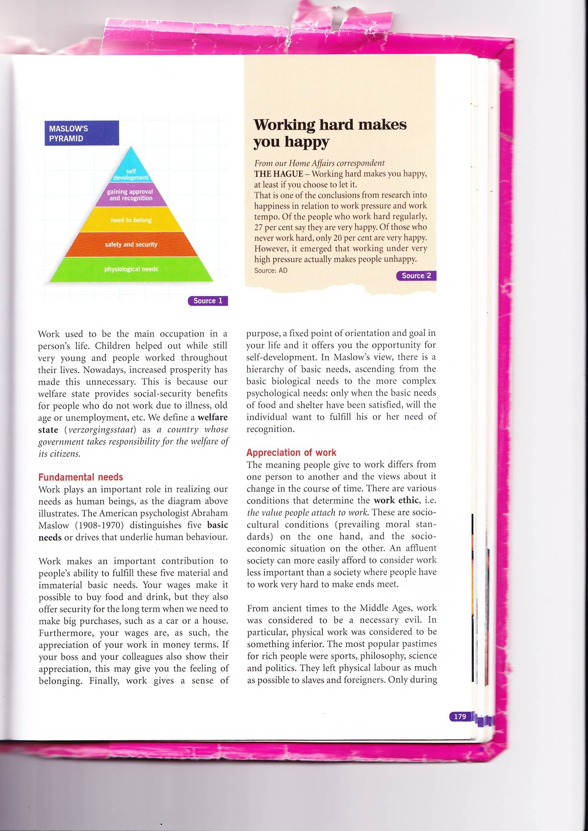

Maslow’s pyramid distinguishes five basic needs relating to work and the important role of it as human beings. There is a hierarchy: ascending from the basic biological needs to the more complex psychological needs.

Work ethic= the value people attach to work: these are social cultural conditions (prevailing moral standards) and the socio-economic situation combined.
Work used to be considered as a necessary evil and physical work especially was considered as sth inferior, it was left to slaves and foreigners while popular pastimes for the rich were sports, science politics etc.
It was not until the 16th century, under the influence of the Calvinism, that people considered work to be a moral duty.
In the 19th century socialism and liberalism emerged and both considered work to be a social duty, people could improve their position in life and contribute to general welfare.
Now work is considered as both a social duty and a means of self-development.

The higher the education, the higher the salary and status. This is linked to the social position of people= the place they have on the social ladder.
Work, your gender, family situation, your social environment are all factors that determine your social position.
People with a high social position have better housing, are healthier and perform better at school and have a longer life expectancy due to less psychological problems.

Appreciation of work has changed over time and one of the issues is the division between typical men’s and typical women’s work, as it is narrowing. Men are now working as nurses and women as police officers.

Social stratification= the layered structure of society where the relationship between the social classes is based on social inequality.
Top managers and capital owners make up the elite of society and people with old age pensions the bottom.
Social inequality= an unequal division of wealth, power and social privileges due to more power or better jobs.
Social mobility= the possibility to climb up or slip down the social ladder. This was practically impossible until WW2. Education and work are the main engines for upward mobility and therefore the government has to ensure that as many people as possible have jobs.

2 The social partners: Have labour relations been regulated in the Netherlands?

Employers and employees are dependent on each other, since employers depend on the work of their employees while employees depend on the salary they receive from their employers. Therefore they are social partners- in the way they deal with each other. It is the basis for the agreements that are made about labour factor, both in companies as well as in society.
Employees have work meetings with their employers, and businesses with more than 50 employees have a works council. The employees are allowed to take part in corporate decision-making on a number of matters through worker participation.
It has the power of co-determination in personnel matters like holiday planning etc. and it has only advisory powers when it comes to decisions on matters affecting business economics like mergers.
They also receive the company’s financial and social annual report.
Conflicting interests between employers and employees occur often and therefore employers’ and employees’ organizations exist.

During the Industrial Revolution people had to work all day long and got paid little money, this changed with the coming of trade unions, who fought for higher wages, shorter working hours etc.
Various trade unions cooperated in the national trade union federation. We have the FNV, Christian CNV and the Unie MHP (middle and higher personnel).
Their aims:
- Terms of employment- negotiations about wages, shorter working hours, job evaluation etc.
- Labour conditions- particularly health, safety and welfare
- Industrial relations- participation in internal corporate decisions on mergers and automation
- Legal position of employees- such as regulations and procedures in the case of dismissal
- Social security-such as maintaining an acceptable level of social security benefits
- Employment- such as encouraging job schemes
Members can appeal to the union individually when have trouble at their work place, trade unions often try to act as a mediator. Trade unions will always negotiate as the first step. They can call several actions: lightning actions, work-to-rule actions, call a strike, sit-in or start legal proceedings.

Employers’ organization:
Organized by employers as a response to trade unions, VNO-NCW focuses on the large businesses while MKB-Nederland focuses on medium-sized and small businesses.
Aims:
- Promote interests of employers in the negotiations with the trade unions
- Promote a favourable employers’ climate by bringing about low costs and a favourable position with regard to foreign competitors
- Promote unity among its members by, e.g., regulating competition between members
- Give mutual support, e.g. assistance funds and examine economic effects of EU measures
Employers’ organizations can use the thread of transferring production to a low-wage country with the loss of job as a result, when having an argument. They may decide to institute legal proceedings in the case of strikes or other actions.

SER= Sociaal-Economische Raad & Stichting van de Arbeid is where the trade unions and employers’organizations meet, on a national level. SER advises the government on social and economic matters, it’s an independent advisory body.
When both parties come to terms, a central agreement is made, serves as a guideline for further negotiations at business sector level.

Business sector= a group of similar businesses, the government is not involved. Their major goal is to make a collective agreement.

CAO= collective agreement, Collectieve Arbeidsovereenkomst, an agreements between employers and employees on terms of employment and all other issues on which agreement is desired. It is an agreement between 1 or more employers’ organizations or trade unions and it applies to all employees within an industry. They are usually valid for one or two years.
It has to be submitted to the Minister for Social Affairs and Employment, if he finds it generally binding, it will apply to all employers and employees in that business.
Secondary terms of employments differ in each company and it is a deciding factor when choosing a job, like a company care, free childcare, chances of promotion etc.

Harmony model= parties(employers & employees) are willing to reach solutions jointly. (CNV & Unie MHP)
Conflict model= the emphasis is on the conflicting interests between employers and employees (FNV).

Trade unions have become more important especially when the country had to reconstructed in the 1950s. In the 1950s and 60s the wage demands increased due to the booming economy while in the 1970s they stagnated. In the 1980s trade unions excepted lower wage demands in exchange for more employment, the collective bargaining model called the polder model.
In the 1990s the economy was once more a success and the polder model received international acclaim for being responsible for this growth.

Many years there has been a transfer of low-skilled employment to low-wage countries (China, India, East bloc) but lately they have also disappeared in the low-wage countries.
There has been an increased influence of investors and shareholders in multinational businesses. They think in terms of returns and demand maximum growth from the management.

3 From night watchman state to welfare state: How did the welfare state come about and what contribution did the liberals, social democrats and Christian democrats make to its development?

Liberals= hand-off style of the government, society progresses best if individuals have as much room for development as possible.
Social democrats= active state intervention in the production process, and maintaining free enterprise-based production, government should improve the position of the disadvantaged and retain control of the production of certain essential goods and services, e.g. gas and electricity, actively operating government.
Christian democrats= employees and employers should organize the economy jointly and in harmony. State only intervenes when that does not work and if disadvantaged people threaten to lose out.

In the 19th century we had the free market economy (a freely operating price mechanism)- everyone produced whatever they wanted, the government did not intervene. Adam Smith is the founder of the free market economy and seen as founder of the traditional liberalism. The law of supply and demand worked through price mechanism like ‘an invisible hand’. The supply and demand issue will continue until a balance is reached.
Therefore the government had a limited role and the Netherlands became a night watchman state, whose task was to ensure the safety of citizens and protect their possessions.
Disadvantages of the free market economy: the bigger the labour pool, the lower people’s wages and no work meant no food for the workers, factory owners did have this luxury and exploited their workers.
State intervened during the 19th century:
- Christian democrats wanted to protect the disadvantaged
- Socialists wanted better living conditions and stronger legal position for workers
- Liberals wanted to reduce crime, it was the consequence of large-scale poverty
Results from this were the social laws:
- Armenwet (1854), under certain conditions people were entitled to financial support
- Van Houten’s Kinderwetje (1874) banned child labour
- Veiligheidswet (1895) improving working conditions
- Arbeidswet (1919) reduced the working day to 8 hours
Governments’ tasks were extended and services arose that led to a new economy, the mixed-market economy= market mechanism in which the government regulated cases and state ownership and management of certain means of production.

The recession in the 1930’s brought poverty to the Netherlands and there was no government intervention. WW2 increased the need of government intervention in the socioeconomic field even more. There was cooperation between different parties because of the growing need and readiness to cooperate.

Since 1945: Catholic party KVP and social democrats PvdA formed the backbone of most cabinets. Money was scarce and wages were kept low so the controlled incomes policy was introduced: government decided how high wages were allowed to go. A compromise was reached: social democrats got their new social laws and the denominationals got consultative bodies like the SER.

Algemene Ouderdoms Wet (AOW) was introduced in 1956 by Willem Drees (PM), it provided breadwinners with a permanent income after they turned 65/
National Health Service (Ziekenfonds) took care of people’s welfare and the medical expenses.
The social security system had become the backbone of society and was vitally important as it made NL a real welfare state with services in all possible fields.

4 Socioeconomic aims: What role does the government play in the socioeconomic field, particularly in the labour market?

The SER, in 1951, formulated 5 important aims for the government’s economic policy:
- Stable economic growth- economic activity is evenly spread across the country and not achieved at the expense of other needs, like the environment. Most employment is available in the Randstad and the government is trying to make it more attractive for companies to set up a business elsewhere.
- Fair distribution of income- the differences in income should not be too big, we achieve this through (this is the most explicit political goal):
Progressive tax system- people who earn more, pay more income tax
Setting a minimum wage- based on the amount someone needs to get by
Social security benefits for people who cannot make an independent living themselves
Subsidies- like rent and health care subsidies for people whose incomes are too low
- Stable balance of payments- it’s an overview of all cross-border cash flows and mainly consist of import and export of goods and services. A balance of payments equilibrium is beneficial to our economy. The credits and debets on the balance of payments have a substantial effect on the other aims and vice-versa. By not allowing wages to rise as fast as in other countries, we keep a stronger trading position.
- Stable price levels- domestic price rises are kept under control by the government in order to maintain consumer purchasing power. A decrease in purchasing power causes inflation. The government consults the Labour Foundation during the autumn wage negotiations on prices/wages/inflation and on the policy of terms of employment. The minister of Social Affairs can impose wage restraints on all business sectors through legislation.
- Stable labour market- a place where those who supply labour and those who demand it meet. It consists of the working population, all people from 15/65 able to work for at least 12 hours a week. The demand for workers is aka employment.
Unemployment= when the demand for work is greater than the supply:
Frictional unemployment- employees are in between jobs and out of work for a short time
Seasonal unemployment- as a result of seasonal activities (e.g. on the beach)
Cyclical unemployment- in periods of economic recession; temporary decline for demand
Structural unemployment- when work disappears structurally, as a result of e.g. automation
There is never an ideal balance of full employment and unemployment is a normal state of affairs.

Factors that were increased thanks to the five aims:

Globalization- some forms of employment disappeared from NL like labour-intensive employment, as it has been moved to low-wage countries, this can apply for any kind of work. Globalization spreads all over the world, especially with an economic crisis like in the US at the end of 2008.

Increasing demand for schooling- the Netherlands is an attractive place to set up a business because of the good services and highly educated employees. This means that new employment emerges needing highly educated staff.

Europeanization- persons/goods/capital can move freely across the EU but this can pose a threat as well as present opportunities. A threat in the way of people from other countries coming to work here because they have fewer demands than Dutch people which results in the Dutch losing their jobs. A single common labour market in Europe offers economic growth for Western Europe and economy growth in Eastern Europe (larger market)

Working population changes- lots has changed, more women carry on working after getting married, the characteristics of contemporary unemployment are:
- Young people do not enter the labour market until they are 20
- 90% of the men between 25/60 occasionally work part-time
- 80% of the women between 25/60 often work part-time
- Most older people stop working before becoming 65

Flexible employment- flexible workers are much more needed nowadays because not many people want to commit themselves to a job/company but flexible employees are easier to dismiss.

Labour market under discussion- the labour market in constantly under discussion and many questions arise but they partly depend on one’s political orientation. VVD/CDA/PvdA voters are more
positive on globalization while SP/GroenLinks/CU voters are not.

5 How social security is arranged: What types of welfare state are there and which model applies to NL?

Almost every country in the West has a different type of welfare state, you have:
- Scandinavian model (Finland, Denmark, Sweden): a combination of the flexible labour market and strong social security system: you can easily find another job and many people change jobs often. There are lots of benefits like maternity leave. Disadvantage: it’s very expensive and people pay high taxes; high investment in money and childcare and education. Women have a high level of labour participation- the social democrat model.
- Anglo-Saxon model (UK and US): liberal values like self-sufficiency, private initiative and freedom combined with comprehensive social security. Wages are determined by the market and there is a flexible labour market. Health care and education are capital goods. Private schools and clinics are widely seen. Benefits are short-term and they have a smaller collective sector.
- Rhineland/corporatist model: mixed economy with market mechanisms kept under control by the collective sector and the cooperation between government and social partners. Social security is very important and families with a father as breadwinner are central to the system, meaning women benefit less.
These models can be compared by looking at the efficiency and justice. Models are efficient if it encourages people to work and results in high employment percentages.

Tasks of the government to become a welfare state with socioeconomic aims:
- Economic tasks, stimulating employment and combating inflation
- Corporate tasks, financing and producing goods and services
- Social tasks, providing social security benefits and subsidies
- Welfare tasks, social and sociocultural work
- Cultural tasks, managing libraries and museums
An important part of the welfare state consists of providing benefits and subsidies, they together are termed ‘social security’.

Insurance= people pay premiums to insure themselves against a certain risk.
Social insurances (compulsory) consist of:
- National insurances- everybody with an income pays for this and gets benefits like the AOW Algemene Nabestaandenwet (ANW) and Algemene Kinderbijslagwet (AKW)
- Employees insurances- especially intended for employees, jointly paid by employers and employees, they are implemented by the UWV, 3 most important ones:
  - WW (Werkeloosheidwet) provides an income if employees become unemployed
  - WULBZ (Wet uitbreiding loondoorbetalingsplicht bij ziekte) it obliges employers to pay a sickness benefit to the employee in the case of illness, max. period is 2 years
  - WIA (Wet werk en inkomen naar arbeidsvermogen) employees who are unable to work due to long illness/accident receive an income

Social services= for people who cannot claim social insurance because they have not yet worked (example), no contributions are paid. Best known social service is social assistance, a safety net under the social security system provided in the WWB (Wet werk en bijstand). People unable to find a job gets help and income support in the form of social assistance, there are 2 forms:
General assistance- minimum monthly amount for necessary expenses (food/clothes etc.)
Supplementary assistance- unusual, additional expenses, amount of money is determined for you

One has the obligation to apply for jobs but also the right to assistance, but if you do not look for a job actively you are denied assistance. But there is also free choice of work meaning the government cannot for you to get a job.

One last thing: employees pay contributions to the compulsory national and employees’ insurance.
6 The welfare state under pressure:

Shortly after the welfare state was established problems emerged: they threatened to make the social security system unaffordable.
The social security system developed in the 60s was family-based because men were the breadwinners, however this changed in the late 60s when more women joined the labour market. They demanded the same rights because they also paid contribution, they got their rights but this meant that substantial increase in the number of benefits.
The system started to be used improperly: people who were perfectly healthy claimed to be ‘sick’ and not able to work and thus got a disability benefit, which is higher than an unemployment benefit. This resulted in calculating behavior- people in employment became more self-interested and started moonlighting (zwart werken)to avoid paying social contributions.
In 1973, due to an oil crisis, unemployment rose and this caused an increase in the number of benefits and in public expenditure. The government had to raise social security contributions to get around to paying the benefits. Something had to be done to maintain the welfare state.

Measures that were taken:
On the supply side, fewer workers- a shorter working week was introduced (36 hours) and the voluntary early retirement scheme (VUT) was introduced, which enable employees to retire earlier.

On the demand side, more employment- rate of the income tax and social contributions were lowered, employment was promoted by businesses, large-scale projects were launched; creating jobs, the government bought products from Dutch trade and industry; in its capacity as an institution, provided supplementary employment for low-skilled long-term unemployed people (ID Scheme) the idea was to take regular employment in the course of time.

Cuts- unemployment benefits (WW) became dependent on the years someone had worked and granted for 5 years at most, suitable employment has been broadened (unemployed person cannot refuse a job easily), medical examination has become stricter for disable people (WIA)

WIA- persons with fully/permanently disabled qualify for benefits: if you are aged 18/21 you get social assistance, retrieval responsibility has been imposed, checks on social assistance benefits have become stricter, cutbacks have been made on all kinds of services.

Poverty trap leads to the permanent dependence on benefits: being dependant on benefits only.
But measures have been taken to change this: more privatization in the implementation of social security and more emphasis on people’s own responsibility.
Little effort was put into the reintegration of employees who were ill and to improve this, the free market was introduced and benefits were provided.

Government took measures for poor working conditions:
- Arbo-wet; directives in the field of safety/health/welfare, every employer must draw a plan to reduce the sick leave
- WULBZ, employers have been obliged to pay sick employees 70% of their wages for 2 years, in the hope this will stimulate employers to get their employees back to work asap
- Wet Poortwachter, employers and employees have a more active role in the reintegration process
- Zorgverzekeringswet, everybody is responsible for his own health insurance

